This is a title

To use this letterhead just make a copy of this document and all the formatting will be exported.

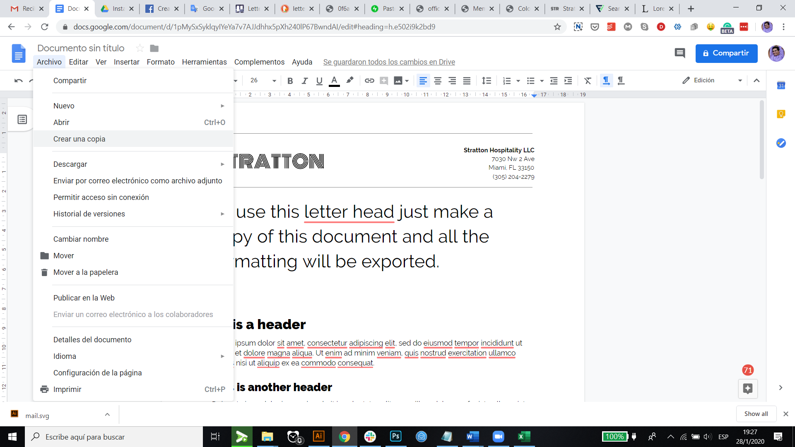

This is template is for online use. If you download and open this document within MS Word, fonts will change.

# [Heading 1]

Lorem ipsum dolor sit amet, consectetur adipiscing elit, sed do eiusmod tempor incididunt ut labore et dolore magna aliqua. Ut enim ad minim veniam, quis nostrud exercitation ullamco laboris nisi ut aliquip ex ea commodo consequat.

## User heading option to create headings instead of making the font bigger. [Heading 2]

Duis aute irure dolor in reprehenderit in voluptate velit esse cillum dolore eu fugiat nulla pariatur. Excepteur sint occaecat cupidatat non proident, sunt in culpa qui officia deserunt mollit anim id est laborum.

### If you think the other headings are too big, use this. [Heading 3]

### This is a letter example

Jane Smith

Director, Human Resources

Fit Living

123 Business Rd.

Business City, NY 54321

**Dear Ms. Smith:**

I’m writing to apply for the position of Social Media Manager for Fit Living, as advertised on your website careers page. I have three years of experience as a Social Media Assistant for Young Living, and I believe I am ready to move up to the manager position.

In your job posting, you mention that you want to hire a Social Media Manager who understands the Internet and social media trends. During my time at Young Living, I was given the responsibility of increasing follower numbers on Instagram. I explained to my manager that I would be happy to do so and that I would also work hard to increase follower participation because engagement has become an important metric.

Within six months, I increased our followers by over 50 percent and increased engagement by 400 percent. I’m very proud of that accomplishment. Currently, I’m working to build a following with the best influencers in our niche.

When I saw the job opening, I knew it was the perfect opportunity to offer you both my social media marketing skills and people skills. I’ve included my resume so you can learn more about my educational background and all of my work experience. Thank you for your time and consideration.

Please feel free to email me or call my cell phone at 555-555-5555. I hope to hear from you soon.

Sincerely,

_________________________________

Your Signature (hard copy letter)

Joseph Q. Applicant